**Electrical Principals**

1. **Instructions**

Work in groups of four. You have two supervised laboratory sessions to work on the practical - you will need to continue work on the laboratory through out the following week, such that you are in a position to be able commence work on Task 10 for the next supervised laboratory. Outstanding sections of the laboratory must be completed in your own time. Task 6 is an individual practical test. You are strongly advised to practice the test before hand.

The completed laboratory should be uploaded into the course's upload system. You should print out the [Marking Scheme](http://staffweb.cms.gre.ac.uk/~sp02/electronics/MarkingScheme.html) and bring a print out of your group's completed laboratory report and the individual [Oscilloscope Test Mark Sheets](http://staffweb.cms.gre.ac.uk/~sp02/electronics/OscilloscopeMarkSheet.html) Laboratory work must be uploaded (pdf format only) within six days of completion of the supervised session, and a paper copy handed in to the tutor at start of the following laboratory

1. **Objectives**
   * The primary objective of this laboratory is to impart competence in the use of standard laboratory equipment - Breadboard, DC Power Supply, Function Generator, Multi-Meter, True RMS Digital Multi-Meter and Analogue Oscilloscope - through the process of experiential learning.
   * To measure the properties of voltage, current and resistance in Direct Current (DC) circuits and verify Ohm's law by experimentation.
   * To measure the properties of Reactance in Alternating Current (AC) circuits.
   * To measure the characteristics of a simple Inductive/Capacitance (L/C) filter.
   * To construct a simple electronic circuit to measure the speed of sound.
2. [**Apparatus**](http://staffweb.cms.gre.ac.uk/~sp02/equipment/equipmentlist.htm)
   * Analogue Oscilloscope & one oscilloscope probe, BNC to BNC Cable, BNC T adaptor, BNC to probe clip cable
   * Breadboard
   * Crocodile Clips Software
   * Function Generator
   * IDC10 Cable x 2
   * Jump Wire Kit
   * Laboratory DC Power Supply + Two sets of Banana leads
   * Multi meter
   * True RMS digital multi-meter
   * Set of resistive and reactive components
3. **Introduction**

It is very common, in the computing/communications industry for prototype devices to be developed which are interfaced to computer systems. To interface to any electronic system requires a basic understanding of electricity. This laboratory introduces the fundamentals of electricity and examines the properties of resistance, capacitance and inductance.

1. **Procedure**
   * **Electrical Units**

|  |  |  |  |  |  |  |  |  |  |  |  |  |  |  |  |  |  |  |  |  |  |  |  |  |  |  |  |  |  |  |  |  |  |  |  |  |  |  |  |  |
| --- | --- | --- | --- | --- | --- | --- | --- | --- | --- | --- | --- | --- | --- | --- | --- | --- | --- | --- | --- | --- | --- | --- | --- | --- | --- | --- | --- | --- | --- | --- | --- | --- | --- | --- | --- | --- | --- | --- | --- | --- |
| TASK 0  Complete the following table:-   |  |  |  |  | | --- | --- | --- | --- | | **Quantity** | **Quantity Symbol** | **SI Unit** | **SI Unit Symbol** | | Potential Difference | E |  |  | |  |  | Ampere |  | |  | Q |  |  | | Power |  |  |  | |  | R |  | Ω | | Inductance |  |  |  | |  |  |  | F | | Reactance |  |  |  | |  | Z |  |  | |

* + **Voltage**

Voltage, also called electromotive force (EMF), is an expression for electric potential or potential difference. If a conductive or semi conductive path is provided between the two points having a relative potential difference, an electric current flows. The quantity symbol for voltage is the uppercase letter E. The SI unit of potential difference is the volt, symbolised by V. One volt is the EMF required to drive one coulomb of electrical charge (6.24 x 1018 charge carriers) past a specific point in one second. Voltage can be either direct or alternating. A direct voltage maintains the same polarity at all times. In an alternating voltage, the polarity reverses direction periodically. The number of complete cycles per second is the frequency, which is measured in hertz (Hertz is a unit of frequency named after the German physicist Heinrich Hertz).

**The Laboratory DC Power Supply**

The laboratory DC Power supply is used to supply power to various equipment and experiments in the hardware / communications laboratory. It has there independent power supplies consisting of: -

* + - two adjustable DC power supplies each capable of delivering a variable voltage between 0 volts 31.5 volts and capable of supplying up to 3 amps
    - one fixed DC supply of 5 volts capable of supplying up to 3 amps.

Front panel mode switches select one of three operation modes for the two adjustable supplies - independent, series and parallel. In the independent mode, the output voltage and current of each supply are controlled separately. The serial or parallel operation allows the two independent supplies to be configured to provide higher voltages of up to 63 volts with a capability of supplying up to 3 amps when connect in series or when configured in parallel 31.5 volts with a capability of supplying up to 6 amps.

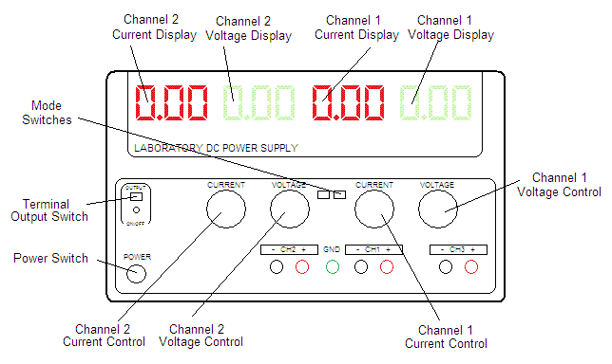

Configure the power supply and breadboard as shown - ensure that both mode buttons of the power supply are out i.e. independent mode.

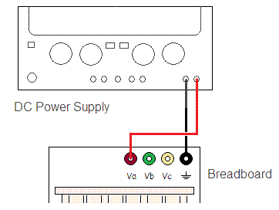

|  |
| --- |
| TASK 1  Set the meter to the 20 volt DC range. Place the black probe tip on black (Gnd) terminal of the breadboard and the red multi-meter probe on the brown (Va) terminal of the breadboard. Record the voltage |

Connect the DC power supply and breadboard as shown - ensure that both mode buttons of the power supply are out i.e. independent mode. Set channel 2 to 8 volts and channel 1 to 10 volts.

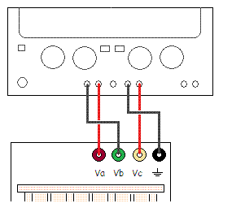

|  |  |  |  |  |  |  |  |  |  |  |  |  |  |  |
| --- | --- | --- | --- | --- | --- | --- | --- | --- | --- | --- | --- | --- | --- | --- |
| TASK 2  Set the meter to the 20 volt DC range. Complete the table with the indicated measurements   |  |  | | --- | --- | | **Breadboard Terminals** | **Meter Reading (V)** | | Green (Vb) to Brown (Va) |  | | Yellow (Vc) to Black (Gnd) |  | | Green (Vb) to Black (Gnd) |  | | Brown (Va) to Yellow (Vc) |  | | Brown (Va) to Black (Gnd) |  | | Green (Vb) to Yellow (Vc) |  | |

WARNING. The power supply is now to be configured such that the two adjustable supply voltages are in serial. UNDER NO CIRCUMSTANCES turn channel 1 and channel 2 voltages up to full which would result in voltages of greater than 60 volts DC appearing at the terminals. Voltages of more than 50 volts DC can be a LETHAL shock hazard.

Modify the above configuration by connecting the breadboard terminals Brown (Va) to Black (Gnd) via a banana lead as shown below - ensure that both mode buttons of the power supply are out i.e. independent mode. Set channel 2 to 8 volts and channel 1 to 10 volts. Before turning on the terminal output switch, double check all connections and double check that channel 2 is set to 8 volts and channel 1 to 10 volts. If you are uncertain, get the tutor to double check the connections and settings for you.

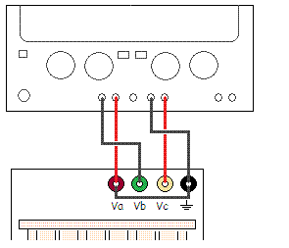

|  |  |  |  |  |  |  |  |  |  |  |  |  |  |  |  |  |  |  |  |  |  |
| --- | --- | --- | --- | --- | --- | --- | --- | --- | --- | --- | --- | --- | --- | --- | --- | --- | --- | --- | --- | --- | --- |
| TASK 3  For the following table discuss with your colleagues what voltages you expect to see across the breadboard terminal pairs. Showing workings, calculate the expected potential difference across the terminals. Complete the Calculated Potential Difference column of the table.   |  |  |  | | --- | --- | --- | | **Breadboard Terminals** | **Calculated Potential Difference (V)** | **Meter Reading (V)** | | Green (Vb) to Brown (Va) |  |  | | Yellow (Vc) to Black (Gnd) |  |  | | Brown (Va) to Yellow (Vc) |  |  | | Brown (Va) to Black (Gnd) |  |  | | Green (Vb) to Yellow (Vc) |  |  | | Green (Vb) to Black (Gnd) |  |  |   Measure the potential difference across the terminals, and complete the table. Explain any differences  (if any) between the calculated values and the measured values.  Disconnect the power supply from the breadboard. |

* + **Resistance**

Resistance is the opposition that a substance offers to the flow of electric current. It is represented by the uppercase letter R. The standard unit of resistance is the ohm, and is symbolised by the uppercase Greek letter omega (Ω). When an electric current of one ampere passes through a component across which a potential difference (voltage) of one volt exists, then the resistance of that component is one ohm.

|  |  |  |  |
| --- | --- | --- | --- |
| 1 = 1st digit, | 2 = 2nd digit, | 3 = Multiplier, | 4 = Tolerance |

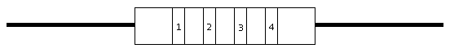

|  |  |  |  |
| --- | --- | --- | --- |
| **Colour** | **Digit** | **Multiplier** | **Tolerance** |
| Black | 0 | 1 | - |
| Brown | 1 | 10 | ±1% |
| Red | 2 | 100 | ±2% |
| Orange | 3 | 1 k | - |
| Yellow | 4 | 10 k | - |
| Green | 5 | 100 k | ±0.5% |
| Blue | 6 | 1 M | ±0.25% |
| Violet | 7 | 10 M | ±0.1% |
| Grey | 8 | 100 M | ±0.05% |
| White | 9 | - | - |
| Gold |  |  | ±5% |
| Silver |  |  | ±10% |
| None | - | - | ±20% |

|  |  |  |  |  |  |  |  |  |  |  |  |  |  |  |  |  |  |  |  |  |  |  |  |  |  |  |  |  |  |  |  |  |  |  |  |  |  |  |  |  |  |  |  |  |  |  |  |  |
| --- | --- | --- | --- | --- | --- | --- | --- | --- | --- | --- | --- | --- | --- | --- | --- | --- | --- | --- | --- | --- | --- | --- | --- | --- | --- | --- | --- | --- | --- | --- | --- | --- | --- | --- | --- | --- | --- | --- | --- | --- | --- | --- | --- | --- | --- | --- | --- | --- |
| TASK 4  For three of the resistors on the breadboard, note the value indicated by the colour code, measure the resistance with a multi-meter and calculate the percentage difference between the two values. e.g.   |  |  |  |  |  |  |  |  | | --- | --- | --- | --- | --- | --- | --- | --- | | Resistor | 1st Digit Colour and Value | 2nd Digit Colour and Value | Multiplier Colour and Value | Tolerance Colour and value | Colour Code Value | Measured  Value | % Difference | | Resistor 8 | Colour = Blue Value = 6 | Colour = Grey Value = 8 | Colour = Red Value = 100 | Colour = Gold Value = ±5% | 6.8 kΩ | 6.698 kΩ | 1.5 % |   Complete the following table:-   |  |  |  |  |  |  |  |  | | --- | --- | --- | --- | --- | --- | --- | --- | | Resistor | 1st Digit Colour and Value | 2nd Digit Colour and Value | Multiplier Colour and Value | Tolerance Colour and value | Colour Code Value | Measured  Value | % Difference | | Resistor 1 |  |  |  |  |  |  |  | | Resistor 2 |  |  |  |  |  |  |  | | Resistor 3 |  |  |  |  |  |  |  | |

* + **Current**

Current is a flow of electrical charge carriers, usually electrons or electron-deficient atoms. The symbol for current is the uppercase letter I. The standard unit is the ampere, symbolised by A. One ampere of current represents one coulomb of electrical charge (6.24 x 1018 charge carriers) moving past a specific point in one second. Electric current can be either direct or alternating. Direct Current (DC) flows in the same direction at all points in time, although the instantaneous magnitude of the current might vary. In an Alternating Current (AC), the flow of charge carriers reverses direction periodically. The number of complete AC cycles per second is the frequency, which is measured in hertz.

Set the true RMS digital multi-meter to measure current. Set the range to 20 mA DC.

Construct the following circuit. If you are uncertain on how to use the breadboard. Read the [Breadboard Guide](http://staffweb.cms.gre.ac.uk/~sp02/equipment/breadboard.htm) and watch [How to Use a Breadboard](http://www.youtube.com/watch?v=oiqNaSPTI7w) If you are struggling, Google 'measuring current with a multimeter' on youtube.

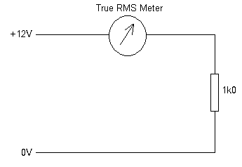

The current which passes through the resistor also passes through the meter and the value is displayed.

|  |  |  |  |  |  |  |  |  |  |  |  |  |  |  |  |  |  |  |  |  |
| --- | --- | --- | --- | --- | --- | --- | --- | --- | --- | --- | --- | --- | --- | --- | --- | --- | --- | --- | --- | --- |
| TASK 5  Showing workings, calculate the expected current using Ohm's Law (Ohm's Law, V = I.R is the mathematical relationship among electric current, resistance, and voltage. The principle is named after the German scientist Georg Simon Ohm). Calculate the power dissipated in the resistor. Where does the energy supplied to the resistor go? Repeat the procedure using the 10 kΩ, 100 kΩ and 1 MΩ resistors   |  |  |  |  | | --- | --- | --- | --- | | Resistor | Calculated Current | Measured Current | Calculated Power | | 1 kΩ |  |  |  | | 10 kΩ |  |  |  | | 100 kΩ |  |  |  | | 1 MΩ |  |  |  | |

* + **AC Voltages**

One of the most common AC voltage is the sine wave. There are three ways to quantify the magnitude of a sine wave.

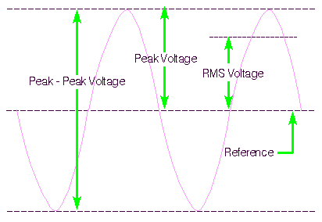

* + - Peak voltage indicates how far the voltage swings, either positive or negative, from the point of reference (normally 0 volts).
    - Peak-Peak Voltage is rarely used. It is used in cases of a non-symmetrical wave forms.
    - RMS voltage is the most common way to measure/quantify AC voltage. It is also the most useful because as AC voltage is constantly changing and is at or near the highest and lowest points in the cycle for only a tiny fraction of the cycle, the peak voltage is not a good way to determine how much work can be done by an AC power source. DC voltage is constant and its voltage level can be plugged directly into the formulas for power and Ohm's law and you will get an accurate image of its ability to do work. RMS voltage will give you the same ability to predict how much work will be done by an AC voltage. The RMS voltage of a pure sine wave is 1/√ 2 peak voltage (approximately 0.707 x peak voltage). If you read voltage with a multi-meter you are generally given the RMS or average voltage of the wave form, not the peak or peak-peak voltage.

If the waveform isn't a pure sine wave (like a triangle wave or a signal with mixed sine waves of different frequencies or music), multiplying the peak times .707 will not give an accurate RMS value and therefore will not give an accurate indication of the work that the waveform can produce when driving a load. For more complex signals, you need a meter that will calculate the RMS value from a set of samples taken at regular intervals such as the true RMS voltmeter.

To determine the RMS value of a waveform (Note- you would not normally be expected to do this calculation in year 1. I have included it here for interest only), three mathematical operations are carried out on the function representing the AC waveform:

* + - The square of the waveform function is determined.
    - The function resulting from step (1) is averaged over the period of the waveform.
    - The square root of the function resulting from step (2) is found.

i.e.

http://staffweb.cms.gre.ac.uk/~sp02/electronics/images/rmsfunction.gif

**Example**

Calculate the RMS value of a sine wave

http://staffweb.cms.gre.ac.uk/~sp02/electronics/images/rmssineform.gif

For the keen: Calculate the RMS voltages for a Square, Saw Tooth and Triangular waveforms. [Solution](http://staffweb.cms.gre.ac.uk/~sp02/electronics/solutions.html)

**Frequency and Period**

If a signal repeats, it has a frequency. The frequency is measured in hertz (Hz) and equals the number of times the signal repeats itself in one second (the cycles per second). A repeating signal also has a period (T) - this is the amount of time it takes the signal to complete one cycle. Period and frequency are reciprocals of each other, so that 1/T equals the frequency (f) and 1/f = T. So, for example, the sine wave in following figure has a frequency of 3 Hz and a period of 1/3 second.

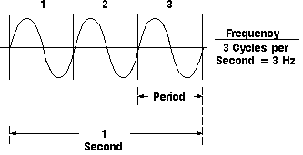

**Example**

A signal has a period T of 5µs, state it's frequency.

|  |  |  |  |  |
| --- | --- | --- | --- | --- |
| f | = | |  | | --- | | 1 | | T | |
| f | = | |  | | --- | | 1 | | 5x10-6 | |
| f | = | 200 kHz |

**Example**

The frequency of a signal is 200 MHz, state it's period.

|  |  |  |  |  |
| --- | --- | --- | --- | --- |
| T | = | |  | | --- | | 1 | | f | |
| T | = | |  | | --- | | 1 | | 200x10+6 | |
| T | = | 5 ns |

|  |  |  |  |  |  |  |  |  |  |  |  |  |  |  |  |  |  |  |  |  |  |  |  |  |  |  |  |  |  |  |  |  |  |  |  |  |  |  |  |  |  |  |  |  |  |  |  |  |  |  |  |  |  |  |  |  |  |  |  |  |  |  |  |  |  |  |  |  |  |  |  |  |  |  |  |  |  |  |  |  |  |  |  |  |  |  |  |  |
| --- | --- | --- | --- | --- | --- | --- | --- | --- | --- | --- | --- | --- | --- | --- | --- | --- | --- | --- | --- | --- | --- | --- | --- | --- | --- | --- | --- | --- | --- | --- | --- | --- | --- | --- | --- | --- | --- | --- | --- | --- | --- | --- | --- | --- | --- | --- | --- | --- | --- | --- | --- | --- | --- | --- | --- | --- | --- | --- | --- | --- | --- | --- | --- | --- | --- | --- | --- | --- | --- | --- | --- | --- | --- | --- | --- | --- | --- | --- | --- | --- | --- | --- | --- | --- | --- | --- | --- | --- |
| TASK 6  If you are uncertain how to use an oscilloscope - read the [Oscilloscope Guide](http://staffweb.cms.gre.ac.uk/~sp02/equipment/oscilloscopeguide.htm)  Using the oscilloscope, set the function generator output from the 50 Ω socket such that the peak to peak voltage of the signal is 20 V and the frequency is 1 kHz. Adjust the time base (Time/Div control) to show one or two complete cycles and calculate the period (T) and peak amplitude (A). For each of the sinusoidal, square and triangle waveforms use the oscilloscope to measure peak to peak voltage and the frequency of the waveforms. Calulate the RMS value. Use the true RMS digital multi-meter to measure the RMS value of the waveforms to confirm your calucaltions.   |  |  |  |  |  |  |  |  | | --- | --- | --- | --- | --- | --- | --- | --- | | Signal Type | Oscilloscope Setting Volts/Div | Peak - Peak  (Show Workings) | Peak (Show Workings) | Calculated RMS (Show Workings) | Oscilloscope Setting Time/Div | Period (T) (Show Workings) | Frequency (f) (Show Workings) | | Sinusoidal |  |  |  |  |  |  |  | | Square |  |  |  |  |  |  |  | | Triangle |  |  |  |  |  |  |  |   TEST  Before undertaking this test, ensure that you are competent in the use of the oscilloscope. I suggest you practice on each other first. When you are ready, call the tutor.  The tutor will randomly change the settings on the oscilloscope and signal generator, you will have to correct the oscilloscope controls so that the signal is displayed correctly, and measure the peak - peak voltage, calculate the peak and RMS voltage values, and measure the period and calculate the frequency. You will not have acces to the true RMS digital multi-meter.   |  |  |  |  |  |  |  |  | | --- | --- | --- | --- | --- | --- | --- | --- | | Signal Type | Oscilloscope Setting Volts/Div | Peak - Peak (Show Workings) | Peak (Show Workings) | Calculated RMS (Show Workings) | Oscilloscope Setting Time/Div | Period (T) (Show Workings) | Frequency (f) (Show Workings) | |  |  |  |  |  |  |  |  | |  |  |  |  |  |  |  |  | |  |  |  |  |  |  |  |  | |  |  |  |  |  |  |  |  | |  |  |  |  |  |  |  |  | |  |  |  |  |  |  |  |  | |

|  |
| --- |
| TASK 7  Lissajous figures are displays on the oscilloscope screen, which are easy to set up.  Connect a second signal generator to the second input of the oscilloscope. Change the display type of the oscilloscope to X-Y display by pressing the X-Y button.  The oscilloscope is now acting as an X-Y plotter. Keeping one output at 600 Hz, adjust the other frequency generator until a simple stable pattern is obtained, without too many loops. Record the frequencies and determine the relationship between the frequencies of the two signals and the number of loops present. |

* + **Capacitance and Inductance**

Two important properties in AC (alternating current) circuits are those of capacitance and inductance.

**Capacitance**: - A capacitor is a passive electronic component that stores energy in the form of an electrostatic field. In its simplest form, a capacitor consists of two conducting plates separated by an insulating material called the dielectric. The capacitance is directly proportional to the surface areas of the plates, and is inversely proportional to the separation between the plates. Capacitance also depends on the dielectric constant of the substance separating the plates.

The standard unit of capacitance is the farad, abbreviated F. This is a large unit; more common units are the microfarad, abbreviated µF and the picofarad, abbreviated pF.

There are many types of capacitor but they can be split into two groups, polarised and un-polarised. Each has its own circuit symbol.

|  |  |  |  |  |
| --- | --- | --- | --- | --- |
| **Polarised capacitors (large values, 1µF plus)** | | | | |
| Examples | polarised capacitor | Circuit Symbol | polarised symbol | Polarised capacitors must be connected the correct way round; one of the leads will be marked + or -. |

|  |  |  |  |  |
| --- | --- | --- | --- | --- |
| **Un- polarised capacitors (small values values, up to 1µF)** | | | | |
| Examples | Capacitors | Circuit Symbol | Capacitor Symbol | Un-polarised capacitors may be connected either way round. |

**Inductance:** - An inductor (Choke) is a passive electronic component that stores energy in the form of a magnetic field. In its simplest form, an inductor consists of a wire loop or coil. The inductance is directly proportional to the number of turns in the coil. Inductance also depends on the radius of the coil and on the type of material around which the coil is wound. For a given coil radius and number of turns, air cores result in the least inductance. dielectric materials such as wood, glass, and plastic are essentially the same as air for the purposes of inductor winding. Ferromagnetic substances such as iron, laminated iron, and powdered iron increase the inductance obtainable with a coil having a given number of turns. In some cases, this increase is on the order of thousands of times. The shape of the core is also significant. Toroidal (donut-shaped) cores provide more inductance, for a given core material and number of turns, than solenoidal (rod-shaped) cores.

The standard unit of inductance is the Henry, abbreviated H. This is a large unit. More common units are the micro Henry, abbreviated µH and the milli Henry, abbreviated mH.

|  |  |  |  |
| --- | --- | --- | --- |
| Examples | Inductor | Circuit Symbol | Inductor Symbol |

**Reactance**

We have seen that resistance, denoted R, is a measure of the extent to which a substance opposes the movement of electrons among its atoms. The more easily the atoms give up and/or accept electrons, the lower the resistance,

Reactance, denoted X, is a form of opposition that electronic components exhibit to the passage of alternating current because of their capacitance or inductance

The equation for calculating the amount of inductive reactance in an AC circuit is given by:

XL = 2 π f L

where: XL = inductive reactance ohms (Ω)

f = frequency in hertz (Hz)

L = inductance in henries (H)

**Examples**

* + - What is the value of inductive reactance for an 0.1 H coil that is operating at 1 kHz? *Answer:* 628 Ω
    - What value inductor is required for producing an inductive reactance of 1 kΩ at 1.8 kHz? *Answer:* 88.4 mH
    - At what frequency will a 150 mH inductor have an inductive reactance of 150 Ω *Answer:* 159 Hz

The amount of inductive reactance XL changes proportionally with the applied frequency f

|  |  |
| --- | --- |
| http://staffweb.cms.gre.ac.uk/~sp02/electronics/images/InductorXL.gif | * + - Increasing the frequency causes XL to increase.     - Decreasing the frequency causes XL to decrease. |

The equation for calculating the amount of capacitive reactance in an ac circuit is given by:

XC = 1 / (2 π f C)

where: XC = capacitive reactance in ohms (Ω)

f = frequency in hertz (Hz)

C = capacitance in farads (F)

**Examples**

* + - What is the value of capacitive reactance for a 10 nF capacitor operating in a 200 kHz circuit? *Answer:* 79.6 *Ω*
    - What value of capacitance is required for producing a capacitive reactance of 120 Ω when 1.2 MHz is applied to it? *Answer:* 1.1 nF
    - At what frequency will the XC of a 1 mF capacitor be 1.2 kΩ? *Answer:* 133 mHz

The amount of capacitive reactance XC changes inversely with the applied frequency f

|  |  |
| --- | --- |
| http://staffweb.cms.gre.ac.uk/~sp02/electronics/images/CapactorXC.gif | * + - Increasing the frequency causes XC to decrease.     - Decreasing the frequency causes XC to increase. |

**Impedance**

Impedance, denoted Z, is an expression of the opposition that an electronic component, circuit, or system offers to alternating and / or direct electric current. Impedance is a vector (two-dimensional) quantity consisting of two independent scalar (one-dimensional) phenomena: resistance and reactance.

**LCR Circuits**

By combining inductors, capacitors and resistors together, the property of impedance varying with frequency can be used to construct filters.

|  |  |  |  |  |  |  |  |  |  |  |  |  |
| --- | --- | --- | --- | --- | --- | --- | --- | --- | --- | --- | --- | --- |
| TASK 8  Identify which graphs represent, a low pass filter, a high pass filter, a band pass filter and band reject filter.   |  |  |  |  | | --- | --- | --- | --- | | Filter Plot | Filter Type | Filter Plot | Filter Type | | Filter Plot |  | Filter Plot |  | | Filter Plot |  | Filter Plot |  | |

|  |  |  |  |  |  |  |  |  |
| --- | --- | --- | --- | --- | --- | --- | --- | --- |
| TASK 9  By considering the characteristics of capacitance and inductance. Identify which of the circuits is a low pass filter and a high pass filter   |  |  |  |  | | --- | --- | --- | --- | | Filter Circuit | Filter Type | Filter Circuit | Filter Type | | Circuit |  | Circuit |  | |

|  |  |  |  |  |  |  |  |  |  |  |  |  |
| --- | --- | --- | --- | --- | --- | --- | --- | --- | --- | --- | --- | --- |
| TASK 10  On the breadboard, construct the low pass filter using the 100 mH inductance (L) , 4.7 nF capacitance (C) and the 6.8 kΩ resistance (R0). If you are uncertain on how to use the breadboard. Read the [Breadboard Guide](http://staffweb.cms.gre.ac.uk/~sp02/equipment/breadboard.htm) and watch [How to Use a Breadboard](http://www.youtube.com/watch?v=oiqNaSPTI7w).   |  |  |  | | --- | --- | --- | | 100 mH Inductance | 4.7 nF Capacitance | 6.8 kΩ resistance | | 100 mH Inductance | 4.7 nF Capacitance | 6.8 kΩ Resistance | | BNC Lead | Proble Clip | Probe | | BNC - BNC Cable | BNC to Probe Clip Cable | Oscilloscope Probe |  * + - Connect the signal generator via the 50 Ω output to channel 1 of the oscilloscope to the input of the filter using a BNC - BNC and a BNC to probe clip cable. Connect the output of the filter via an oscilloscope probe (set to x 1) to channel 2 of the oscilloscope. Trigger from channel 1. Set the function generator to produce a sinusoidal wave form and vary the frequency of the signal generator from low to high, making note of filter's output voltages on the oscilloscope at appropriate frequencies. Plot the response of the filter with frequency on the horizontal scale and the filter's output voltage on a vertical scale.  Take a pictures of the circuit and oscilloscope display to include in your report     - Connect two of the low pass T sections in series (Note you only need one load resistor). Plot the response of the filter with frequency on the horizontal scale and the filter's output voltage on a vertical scale. Take a pictures of the circuit and oscilloscope display to include in your report   Upload the graphs and your observations to your logbook. |

1. **Speed of Sound**

The velocity of sound can be calculated by measuring the time taken for a audio signal transmitted by a loudspeaker to be received by a microphone.

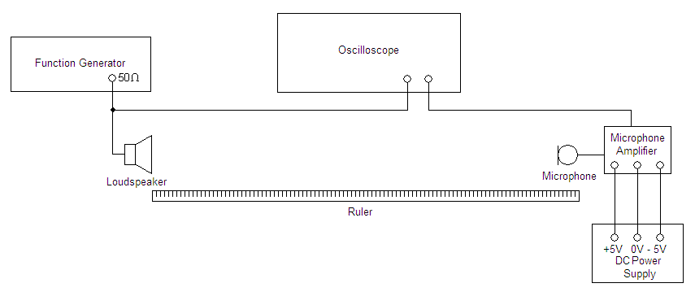

The signal generator produces a periodic signal which is fed to the oscilloscope and the loudspeaker, the microphone detects the sound and the signal is displayed on oscilloscope. The time taken for the sound to travel from the speaker to the microphone can be determined by measuring the phase difference of the function generator signal and the microphone signal.

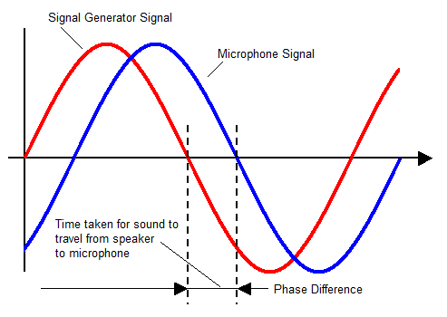

**Microphone Amplifier**

The signal from he microphone needs to be amplified so it can be detected by the oscilloscope. The amplifier circuit is based on the 741 Operational amplifier which is high-gain Integrated Circuit (IC) voltage amplifier with differential inputs and a single output. The output of the op-amp is controlled by feedback, which determines the voltage gain. Op-amps are among the most widely used electronic devices and are incorporated in a vast array of consumer, industrial, and scientific devices.

Using the 741 Operational Amplifier, construct the following circuit on the breadboard. Note, **the 741 amplifier requires a +5 volt supply at pin 7 and a -5 volt supply at pin 4.**

|  |  |  |  |
| --- | --- | --- | --- |
| http://staffweb.cms.gre.ac.uk/~sp02/equipment/images/741.jpg | http://staffweb.cms.gre.ac.uk/~sp02/equipment/images/suntan.png | http://staffweb.cms.gre.ac.uk/~sp02/equipment/images/pot.jpg | http://staffweb.cms.gre.ac.uk/~sp02/equipment/images/microphone.jpg |
| 741 Operational Amplifier | 4.7 uF Capacitance The long leg is the positive lead.  The white stripe running side of the  capacitor indicates the negative lead | Potentiometer | Microphone The red lead is the positive, black is earth |

Connect the DC power supply and breadboard as shown - ensure that both mode buttons of the power supply are out i.e. independent mode. Set channel 2 to 5 volts and channel 1 to 5 volts.

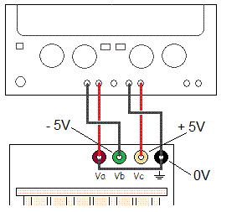

|  |  |
| --- | --- |
| Microphone Circuit | 741 Pinout |

|  |
| --- |
| TASK 11  Measure the speed of sound.  Measure the distance between the speaker and the microphone, and determine the time delay. Move the microphone to a new position and repeat distance and delay measurements. Repeat for at least five sets of distance values. You should repeat measurements and take averages for each distance. On the graph of distance against time, the line will be straight and the gradient will be the speed of sound in air at the temperature of recording. You will need to experiment with different waveforms, frequencies and triggering techniques to determine which are the best settings for the signal generator and the oscilloscope.  Take a pictures of the circuit and oscilloscope display to include in your report  Upload the speed of sound calculations, the graph, details of the signal generator and the oscilloscope settings stating why you choose them, and a discussion on the experiment to your logbook. |

|  |
| --- |
| TASK 12  Identify the sections of the laboratory you have understood and demonstrate your understanding - beyond the simple level of completing the laboratory - through cognitive processes such as analysing, explaining, interpreting, and evaluating. Illustrate, by the use of examples how the laboratory contributed towards your understanding and your Degree programme.  For the sections of the laboratory in which you struggled with, or were uncertain of, identify why this was the case. Evaluate the effectiveness of your learning strategy, including factors such as, motivation, preparation, commitment, time management, communication, constraints and support. With reflection to past experience, identify how you could improve your learning and performance to overcome the barriers encountered in this laboratory such that they do not infringe upon the next laboratory you undertake.  With relation to the sections of the laboratory you encountered difficulty with, state how, and by when you intend to gain competence in these areas.  Critically appraise the laboratory; identify sections you thought were positive, facilitated your understanding and contributed to your Degree programme; identify sections that require improvement and state how and why would you change the laboratory to improve the laboratory for the next year's students. |

• [Apparatus](http://staffweb.cms.gre.ac.uk/~sp02/equipment/equipmentlist.htm) • [Breadboard Guide](http://staffweb.cms.gre.ac.uk/~sp02/equipment/breadboard.htm) • [Oscilloscope Guide](http://staffweb.cms.gre.ac.uk/~sp02/equipment/oscilloscopeguide.htm) • [Technician's Guide](http://staffweb.cms.gre.ac.uk/~sp02/electronics/technicanguide.htm)